Functions – Notes

Find the equation of the curve with equation y = a + k$\sqrt{x+b}$ drawn below:
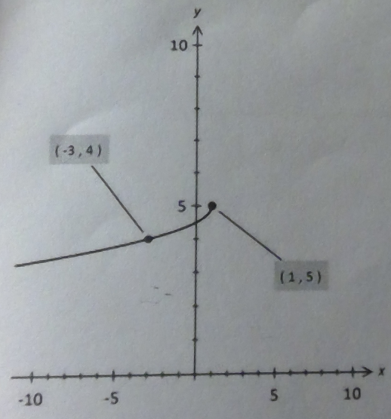
Turning point is (1 , 5) y = a + k$\sqrt{x-1}$ + 5
Flipped over the x-axis and y-axis y = –k$\sqrt{-(x-1)}$ + 5
Simplify y = = –k$\sqrt{-x+1}$ + 5 y = = –k$\sqrt{1-x}$ + 5
Passes through (–3 , 4) Substitute: 4 = –k$\sqrt{-(-3)+1}$ + 5 4 = –k$\sqrt{4}$ + 5 k = – $\frac{1}{2}$

State 2 possible equations for an exponential curve with asymptote y = –2 and vertical intercept (0 , –1).
Vertical asymptote y = –2 y = ka^{-x} – 2
Vertical intercept (0 , –1) k = 1 y = a^{-x} – 2 where a > 0

State 2 possible equations for an exponential curve with asymptote y = 2 and vertical intercept (0 , –3).
Vertical asymptote y = 2 y = ka^{-x} + 2
Vertical intercept (0 , –3) k = –5 y = –5a^{x} + 2 where a > 0

T varies directly with the square root of I and varies inversely with the square root of M. Given that T = 2π when I = 9 and M = 4, find T in terms of I and M.
T = k$\sqrt{\frac{I}{T}}$ = 2π = k$\sqrt{\frac{9}{4}}$ 360° = $\frac{3k}{2}$ k = 240° = $\frac{240π}{180}$ = $\frac{4π}{3}$ T = $\frac{4π}{3}\sqrt{\frac{I}{T}}$

Consider the equation y = f(x) = k(x+2)(x²–3x+c) where k and c are constants. Find the values of k and c if f(–4) = f(–2) = 0 and f(0) = –4.

k(x+2)(x+4)(x+a) = k(x+2)(x²–3x+c) We use the roots to form an equation.
(x+4)(x+a) = x²–3x+c We cancel the common factor out k(x+2).
x² + xa + 4x + 4a = x²–3x+c We factorise.
x² + x(a + 4) + 4a = x²–3x+c We compare the coefficients.
(Comparing coefficients)
a + 4 = –3
a = –7
–4a = c –28 = c We substitute ‘a’ (–7) into when x = 0 in (x+4)(x+a) to find ‘c’.
f(x) = k(x+2)(x²–3x–28) We substitute the value for ‘c’ into the original function.
When y = 0 –4 = k(–56) We know that one of the roots is (–4 , 0)
k = $\frac{–4}{–56}$ = $\frac{1}{14}$ We use algebra to find the value of ‘k’.
f(x) = $\frac{1}{14}$(x+2)(x²–3x–28) We form the final function.
f(x) = $\frac{1}{14}$(x+2)(x–7)(x+4)

State 2 possible equations for a circle with radius 5 and passing through the point with coordinates (4 , 4).
Equation 1: (x+1)² + (y–4)² = 25
Equation 2: (x–9)² + (y–4)² = 25

(4, 4)
(9, 4)
(–1, 4)

Given that f(x) = x², solve f(x) = f(2x+1). Describe clearly how you obtained your answer.

f(x) = x² f(2x+1) = (2x+1)²
Hence, f(x) = f(2x+1) becomes x² = (2x+1)²
x² = 4x² + 4x + 1 x² = 4x² + 4x + 1 3x² + 4x + 1 = 0 3x(x+1) + (x+1) = 0 (3x+1)(x+1) = 0 x = – $\frac{1}{3}$ , –1.

